**Yamhill Community Care Organization**

**Community Health Improvement Plan**

**July 2014 – June 2019**

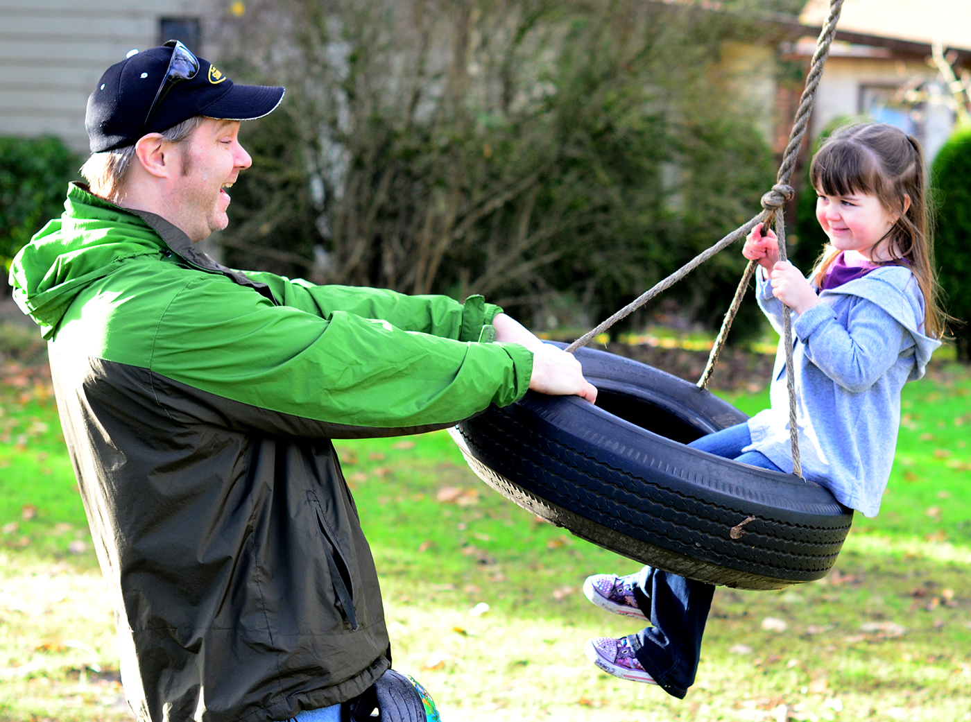

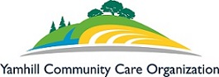

This page is intentionally blank.

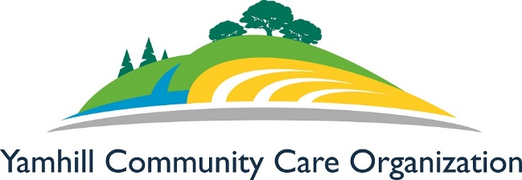

**Community Health Improvement Plan  
Overview:**

**How to read the goals, objectives and strategies of the CHIP:**

The CHIP has four *Priority Goals*, or main focus areas. Each goal has multiple *objectives* and each objective has multiple *strategies*. A goal is a broad, overarching outcome that is desired. An objective is a specific and measurable step taken to reach a goal. A strategy is how the objective is going to be achieved. objective.

The strategies have funding streams and lead role information that will help describe what resources are available to achieve the strategies and who will take ownership of the strategies.

  
 **GOALS AND OBJECTIVES**

|  |  |  |  |
| --- | --- | --- | --- |
| ***Objective*** | | | ***Description*** |
| **Goal 1 Chronic Conditions** | | | |
| 1 | | | Reduce rates of obesity from 29% to 26% in Yamhill CCO adult members and from 12.4% to 11.2% in Yamhill CCO child members by June 2019. |
| 2 | | | Develop regularly offered provider education courses to integrate chronic conditions, mental health, and health literacy topics by December 2015. |
| 3 | | | Increase the number of patient and community education courses offered about chronic conditions available and course participation rates by December 2015. |
| 4 | | | Increase resources available to Yamhill CCO members to manage diabetes and pre-diabetic conditions by December 2016. |
| **Goal 2 Oral Health** | | | | |
| 1 | | | Establish a system to integrate expanded practice dental hygienists with maternal medical homes and preschool expansion programs by August 2016. | |
| 2 | | | Incentivize pediatric medical providers to provide early childhood caries prevention services into the well-child by August 2016. | |
| 3 | | | Expand sealant program for children to all eligible Title 1 schools by August 2016. | |
| 4 | | | Increase preventative and periodontal services for Yamhill CCO patients by June 2017. | |
| 5 | | | Increase tobacco and other drug cessation counseling in dental homes by June 2017. | |
| 6 | | | Community Health Workers, Paramedicine, and Project ABLE peer support specialists will discuss oral health need referrals with 50% of their members by June 2016. | |
| **Goal 3 Leveraging Medical Providers** | | | | |
| 1 | | Implement a system to connect Electronic Health Record clinical data for physical, mental, and oral health providers by December 2017. | | |
| 2 | | Develop and establish a holistic provider recruitment and retention plan that includes physical, behavioral, and oral health providers and staff by June 2017. | | |
| 3 | | Develop Yamhill CCO consumer education materials and classes by June 2015. | | |
| **Goal 4 Behavioral Health** | | | | |
| 1 | | Build upon partnerships with local community-based providers and health partners to offer community health and prevention education courses for Yamhill CCO providers and members by June 2016. | | |
| 2 | | Strengthen crisis outreach and intervention in the community by June 2017. | | |
| 3 | | Expand care coordinated between behavioral and physical health for both co-located and stand-alone clinics for adults and child Yamhill CCO members who are receiving or need to receive mental health services by December 2015. | | |
| 4 | | Expand alcohol and other drug services for Yamhill CCO members by 10% by June 2016. | | |

**Table of Contents**

Executive Summary……………………………………………………………………………….4

Community Health Improvement Plan Development…………………………………………..5-6

Top Community Concerns………………………………………………………………………...5

Vision, Mission, and Guiding Principles………………………………………………………….7

Yamhill Community Care Organization Member Profile……………………………………....8-9

Goals, Objectives and Strategies…………………………………………………………………10

Community Health Improvement Plan Goals………………………………………………..11-26

Goal 1: Chronic Conditions…………………………………………………………..11-14

Goal 2: Oral Health…………………………………………………………………...15-18

Goal 3: Increasing Capacity………………………………………………………….19-21

Goal 4: Behavioral Health……………………………………………………………22-26

Contact Information……………………………………………………………………………...27 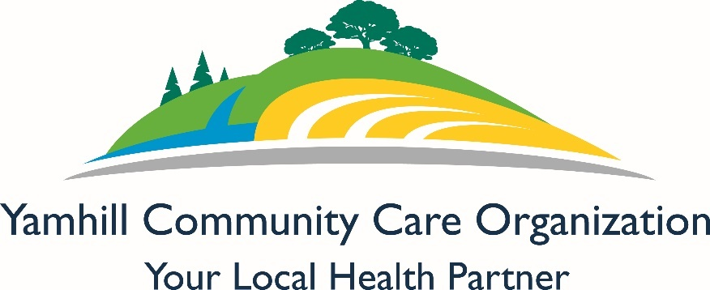

Data compiled in 2014 by: Haleigh Leslie, MPH; Rhianna Wallace, BS

Written and Reviewed by: Haleigh Leslie, MPH; Rhianna Wallace, BS; Veronica Herrera, BS; Anuja Shah, MPH, and Yamhill CCO Community Advisory Council, Clinical Advisory Panel, and Board of Directors.

Front cover photo taken by Eleanor Gorman, 2014

Last Revised date: June 24, 2014

Executive Summary

The Yamhill Community Care Organization (Yamhill CCO) Community Health Improvement Plan (CHIP) is an action-oriented plan designed to address the health needs of Yamhill CCO members through an established set of strategies based on the Community Health Assessment (CHA). The Yamhill CCO Community Advisory Council (CAC) took the lead on developing this CHIP based on the information from the Community Health Assessment, which included data from County Health Rankings, Yamhill CCO and community surveys and focus groups. The CAC members prioritized the top health concerns of Yamhill CCO members. The process involved comparing information received by the community along with information contained in the Yamhill CCO Transformation Plan, the Healthy People 2020 objectives and other resources. The CAC decided on the following four goals as priority through 2019:

* Promote overall well-being by reducing prevalence of chronic conditions.
* Integrate oral health with physical and behavioral health.
* Leverage existing providers and health care teams’ capacities in more innovative and creative ways.
* Value the mind-body connection by integrating behavioral and physical health prevention, education, and treatment.

The CAC held bi-monthly meetings to develop this CHIP which included the objectives and strategies based on the input from Yamhill CCO members, participants in the Latino focus groups, and leveraged current momentum in the community to address health specific needs.

The CAC worked closely with the Clinical Advisory Panel (CAP) and Yamhill CCO Board of Directors in the development of the CHA and CHIP and will continue to work together as the CHIP is implemented, with a goal of meeting monthly to discuss progress toward the CHIP priority goals, objectives, and strategies.

This plan outlines the objectives and strategies that Yamhill CCO and its community partners will pursue over the next five years, and will continually monitor progress to make sure Yamhill CCO is best serving its members. We will continue to engage all of our members and develop new partnerships to increase our capacity to improve the health and well-being of Yamhill CCO members.

Community Health Improvement Plan Development

The Yamhill Community Care Organization (Yamhill CCO) Community Health Improvement Plan (CHIP) was developed by the Yamhill CCO Community Advisory Council (CAC). The CAC is made up of Yamhill CCO members or representatives of CCO members. The development of the CHIP was based upon the results found in the Community Health Assessment (CHA). The MAPP process, Mobilizing for Action through Planning and Partnerships, was used for the assessment. This process included a health status assessment, quality of life survey, community survey, forces of change survey, and environmental scan. We also included focus groups for our Latino population because it is the largest growing race/ethnicity population and is underserved by current resources.

The CAC’s responsibility was to develop the priority areas first and then the goals, objectives, and strategies in the CHIP. The data sources were from County Health Rankings 2013, the Oregon Health Authority, Behavioral Risk Factors Surveillance System, Care Oregon, Yamhill CCO, and from community members by using surveys and holding focus groups. Based on current community support and partnerships, the data collected, incentive metrics, and community input, the CAC determined our four priority areas, through a voting process, as:

Top Four CHIP Health-Related Priorities:

1) Chronic Conditions

2) Oral Health

3) Capacity of Primary Care Providers & Medicaid Enrollment

4) Behavioral Health & Addictions

After selecting the four priority areas, the CAC members began the process of developing goals, objectives, and strategies to address the needs of Yamhill CCO members. The target outcomes are based upon Healthy People 2020, County Health Rankings, and Oregon Health Authority targets so that Yamhill CCO health outcomes can be compared to state and national standards. The goals, objectives and strategies can be found starting on page 10, which also includes information on Funding Streams and an Identified Lead for each strategy. In order to ensure that the outcomes are addressed in multiple ways the CAC learned and used the Socio Ecological Model’s multi-level approach to improving community health. By using this model the strategies developed do not just focus on the person but include the family unit, environment, economy, health care system, policies, and organizations and how these things influence health and well-being.

The CAC members worked through a health disparity and health equity worksheet to help them use the information from the surveys and focus groups to create strategies to make sure we improve health disparities and eliminate health inequities. This worksheet and discussion followed a presentation and discussion from the Oregon Health Authority Office of Equity and Inclusion (OEI). The OEI discussion helped CAC members to better understand the personal stories gathered from the Latino focus groups as well to develop objectives and strategies to eliminate health disparities. The most prominent health disparities and health inequities focus on geographical isolation and the health of the Latino community. These were prioritized because of the number of people they affect. There is a lack of healthcare access in the rural parts of the Yamhill CCO service area as well as a lack of transportation. Through the community surveys and focus groups we found that there is a lack of bilingual-bicultural providers and staff to address the health needs of the Yamhill CCO Latino members. Also identified is a need for more support for Latinos living with diabetes, such as group classes offered in Spanish. Woven within the strategies for each of the four goals are various methods of addressing health disparities such as bilingual and bicultural provider recruitment and retention in the areas of physical, mental, and oral health services; health literacy trainings for providers; developing and distributing culturally and linguistically appropriate member materials. We are committed to researching options to better reach members that are geographically isolated, and developing new partnerships to better serve all members.

The Latino focus groups were instrumental in developing new relationships with the Latino community. These new relationships will allow Yamhill CCO to better serve the Latino community by allowing for regular feedback about services and care provided. Due to the success of these focus groups Yamhill CCO will be researching ways to make a stronger presence throughout its service area to regularly gather input and feedback from all members, with a focus on members that are experiencing the greatest health disparities.

There has also been participation from the Yamhill CCO Clinical Advisory Panel (CAP) and the Early Learning HUB Committee. The CAP has provided feedback on the clinical aspects of the CHIP, which include but are not limited to provider network, partnerships, contracting, cultural competency, interpreters, and health equity issues. The Early Learning HUB is housed within Yamhill CCO and focuses on the development of children and their families. Their input has been valuable in developing the CHA and CHIP because about half of Yamhill CCO members are children. This participation will strengthen the ability of Yamhill CCO to implement these changes to improve the overall health and well-being of its community members.

Yamhill CCO Vision, Mission, and Guiding Principles

The Yamhill CCO Vision, Mission, and Guiding Principles were developed by the Community Advisory Council and agreed upon to guide the development of the Community Health Assessment and Community Health Improvement Plan.

Vision:

“A unified healthy community that celebrates physical, mental, emotional, spiritual and social well-being”.

Mission:

“Working together to improve the quality of life and health of Yamhill Care Organization members by coordinating effective care”.

10 Guiding principles (Values):

* Cost efficiency
* Accountability
* Innovation
* Evidence-Based Clinical Care
* Transparency
* Shared Responsibility
* Member empowerment
* Wellness promotion
* Equity
* Stewardship

**Yamhill Community Care Organization Member Profile**

These three graphs provide a brief picture of Yamhill CCO members. More information about specific health outcomes and factors can be found in the Yamhill CCO Community Health Assessment.

Yamhill CCO, June 2014

Yamhill CCO, June 2014

Yamhill CCO, June 2014

Goals, Objectives and Strategies

Need to update graphs!!!!!!

The goals, objectives, and strategies outline what Yamhill CCO will focus on to improve the health outcomes of Yamhill CCO members from July 1, 2014 to June 30, 2019. As we work through these activities we can change them as we accomplish activities or as more pressing needs arise. Our efforts to improve health outcomes and reduce health disparities will not end with the completion of this CHIP but will continue as we evaluate our health outcomes and strive to develop a culture of health equity for all Yamhill CCO members.

Yamhill CCO will continue to gather the most up-to date information to evaluate and improve the CHA and CHIP. This information will be gathered by getting input from Yamhill CCO members, using population level data of Yamhill CCO members, and from Yamhill CCO partners. This information will be both qualitative and quantitative data that will help evaluate current efforts and plan for future efforts as well as make sure Yamhill CCO is providing quality services. The goal is to gather feedback that is more granular over time and specific to diverse populations. Yamhill CCO will continue to outreach into the community more to get diverse feedback from Yamhill CCO members. From this data and from continuing education we will be able to deepen our understanding of cause, effects, and solutions to address health inequities for Yamhill CCO members. The ultimate goal of this work is to continue addressing health disparities and encourage Yamhill CCO members to take an active role in their health to achieve the Triple Aim of Better Care, Better Health, and Lower Costs.

**How to read the goals, objectives and strategies of the CHIP:**

Each of the four priority areas has a goal. Each goal has multiple objectives and each objective has multiple strategies. A goal is a broad, overarching outcome that is desired. An objective is a specific and measurable step taken to reach a goal. A strategy is how you are going to achieve your objective.

The strategies have funding streams and identified leads information that will help describe what resources are available to achieve the strategies and who will take ownership of the strategies.

**Priority Goal #1**

**Promote overall well-being by reducing prevalence of chronic conditions.**

**Objective #1**: Reduce rates of obesity from the current rate of 29% to 26% in Yamhill CCO adult members and from the current rate of 12.4% to 11.2% in Yamhill CCO child members by June 2019.

|  |  |  |
| --- | --- | --- |
| **Strategies** | **Funding Streams** | **Identified Lead** |
| 1. Increase access and awareness about resources offering healthy affordable food options | Transformation Grant funding | SNACK Program Coordinator, Grant and Project Coordinator |
| 2. Provide education to providers and members on how to choose psychiatric medications with a lower side effect risk of developing metabolic syndrome | Yamhill CCO Global Budget | CAP, Yamhill CCO Medical Director |
| 3. Provide resources for providers needing to educate members who are taking medications to manage metabolic syndrome | Yamhill CCO Global Budget – Provider Education | QCAP, YCHHS, Medical Director |
| 4. Promote participation by members in evidence-based self-management programs | Yamhill CCO Global Budget – CHW Hub | CHW Hub |
| 5. Promote Student Nutrition and Activity Clinic for Kids program throughout Yamhill County clinics serving children | Transformation Funding | Physicians Medical Center, Grant and Project Coordinator |
| 6. Support members who desire to improve their overall health status with healthy lifestyle changes. | Yamhill CCO Global Budget, CHW Hub | CHW Hub |

**Objective #2**: Develop regularly offered provider education courses to integrate chronic conditions, mental health, and health literacy topics by December 2015.

|  |  |  |
| --- | --- | --- |
| **Strategies** | **Funding Streams** | **Identified Lead** |
| 1. Provide annual Adverse Childhood Experiences (ACEs) trainings to develop a better understanding of childhood trauma and chronic conditions (Adverse Childhood Experiences are Verbal, physical or sexual abuse, as well as family dysfunction all of which have been linked to a range of negative health outcomes in adulthood.) | Yamhill CCO Global Budget – Provider Education; Early Learning Program | Medical Director; Early Learning Administrator |
| 2. Regularly offer classes to providers on health literacy and the culture of poverty. | Yamhill CCO Global Budget – Provider Education | Medical Director |
| 3. Develop a referral system and training for providers to connect members with significant mental health challenges and chronic conditions to the appropriate services | Yamhill CCO Global Budget | CHW Hub; YCHHS |
| 4. Provide education to providers on how to talk with members about medications and treatments to make informed decisions about their health | Yamhill CCO Global Budget – Provider Education | QCAP, Medical Director |
| 5. Provide information to providers on how to listen to the physical health needs of patients with high mental health needs. | Yamhill CCO Global Budget – Provider Education | QCAP, Medical Director |
| 6. Research how to cater to the busy schedules of providers | Yamhill CCO Global Budget | Medical Director |

**Objective #3**: Increase the number of patient and community education courses offered about chronic conditions available and course participation rates by December 2015.

|  |  |  |
| --- | --- | --- |
| **Strategies** | **Funding Streams** | **Identified Lead** |
| 1. Increase early education of healthy behaviors and oral health through pediatrician offices | Yamhill CCO Global Budget | Oral Health Coalition; Wellness Center |
| 2. Offer tobacco, prescription drug, and alcohol and other drug use prevention classes for adolescents | Transformation funding; Community Prevention and Wellness | Public Health, Grant and Project Coordinator |
| 3. Promote the services of community health workers in managing chronic conditions | Yamhill CCO Global Budget | CHW Hub |
| 4. Provide culturally sensitive nutrition education information and classes. | Transformation Funds | Early Learning Administrator; SNACK program |
| 5. Develop movement programs for members with chronic conditions to reduce the need for prescription medications. | Transformation Funds, Yamhill CCO Global Budget | CHW Hub |
| 6. Provide education to increase awareness and understanding of mental health challenges. | Yamhill CCO Global Budget | QCAP, CAC, Wellness Center |

**Objective #4**: Increase resources available to Yamhill CCO members to manage diabetes and pre-diabetic conditions by December 2016.

|  |  |  |
| --- | --- | --- |
| **Strategies** | **Funding Streams** | **Identified Lead** |
| 1. Promote blood sugar (hA1c) screenings for all members with diabetes | Yamhill CCO Global Budget | QCAP, Medical Director |
| 2. Recognize the need for regular LDL and hA1c testing status for our population experiencing severe mental health conditions and promote those tests | Yamhill CCO Global Budget | QCAP, Medical Director |
| 3. Increase screening of pre-diabetic members | Yamhill CCO Global Budget | QCAP, Medical Director |
| 4. Partner with NorthWest Senior and Disability Services to promote Diabetes Self-Management Programs for English and Spanish speaking Yamhill CCO members. | Yamhill CCO Global Budget – CHW Hub | NorthWest Senior & Disability Services, CHW Hub |

**Priority Goal #2**

**Integrate oral health with physical and behavioral health.**

**Objective #1**: Establish a system to integrate expanded practice dental hygienists (EPDHs)with maternal medical homes (MMH) and preschool expansion programs by August 2016.

|  |  |  |
| --- | --- | --- |
| **Strategies** | **Funding Streams** | **Identified Lead** |
| 1. Educate healthcare providers and members about Expanded Practice Dental Hygenists (EPDHs, oral health care professionals who can practice independently and outside of a clinic) and other oral health care services | Yamhill CCO Global Budget | Oral Health Coalition, Medical Director |
| 2. Promote importance of preventive dental check-ups and routine dental care to pregnant women at Maternal Medical Homes (clinics designed specifically to support pregnant women with a variety of services) | Yamhill CCO Global Budget | Maternal Medical Home providers, Medical Director, Early Learning Administrator |
| 3. Develop centralized referral process with a dedicated coordinator to facilitate referral of members from Maternal Medical Homes and preschools to an Expanded Practice Dental Hygienists | Yamhill CCO Global Budget | Oral Health Coalition, CHW Hub |

**Objective #2**: Incentivize pediatric medical providers to provide early childhood caries9 prevention services into the well-child visit by August 2016.

|  |  |  |
| --- | --- | --- |
| **Strategies** | **Funding Streams** | **Identified Lead** |
| 1. Reimburse medical providers for oral health screening, fluoride varnish and oral health education when providers’ complete First Tooth or Smiles for Life early childhood cavity education | Yamhill CCO Global Budget | Medical Director |
| 2. Providers caring for pediatric patients share importance of oral health in early childhood development with parents during well-baby checks | Yamhill CCO Global Budget | Pediatricians and other providers that see children, Medical Director |
| 3. Offer group education classes to members and provide information about healthy dental habits for adults and children | Yamhill CCO Global Budget; Early Learning Program | Oral Health Coalition, CAC, Early Learning Administrator |
| 4. Develop centralized referral process with a dedicated coordinator to facilitate referral of members from physical health setting to oral health setting and/or Expanded practice dental hygienists | Yamhill CCO Global Budget | Oral Health Coalition, CHW Hub |

**Objective #3**: Expand sealant program for children to all eligible Title 1 schools by August 2016.

|  |  |  |
| --- | --- | --- |
| **Strategies** | **Funding Streams** | **Identified Lead** |
| 1. Establish baseline data for first molar sealantpercentages and a system to monitor second molar sealants. | Yamhill CCO Global Budget – CCO Metric | Oral Health Coalition, Early Learning Administrator, Quality Department |
| 2. Provide sealants in first and second molars for 6 - 14 year olds in appropriate school setting | Yamhill CCO Global Budget – CCO Metric | Oral Health Coalition, Quality Department |

**Objective #4**: Increase preventative and periodontal services for Yamhill CCO patients by June 2017.

|  |  |  |
| --- | --- | --- |
| **Strategies** | **Funding Streams** | **Identified Lead** |
| 1. Establish baseline data for dental and oral health services already available. | Yamhill CCO Global Budget | Business Intelligence Specialist, Oral Health Coalition |
| 2. Explore the use of teledentistry (a tool that combines telecommunications and dentistry for dental consultation and treatment planning) | Yamhill CCO Global Budget | Oral Health Coalition, Medical Director |
| 3. Investigate options to make higher quality dentures available to patients in need at lower costs | Yamhill CCO Global Budget | Oral Health Coalition |
| 4. Promote referrals from physical health providers to oral health preventative care for diabetic patients. | Yamhill CCO Global Budget | Oral Health Coalition |

**Objective #5**: Increase tobacco and other drug cessation counseling in dental homes by June 2017.

|  |  |  |
| --- | --- | --- |
| **Strategies** | **Funding Streams** | **Identified Lead** |
| 1. Encourage dentists and dental hygienists to provide information regarding tobacco and other drug cessation and incentivize the service by reimbursing dentists. | Yamhill CCO Global Budget | YCPH Health Educator, Medical Director, Oral Health Coalition |
| 2. Provide quit resources to members willing to quit and encourage follow up with members to make sure they make it to scheduled appointments. | Yamhill CCO Global Budget | YCPH Health Educator, CHW Hub |
| 3. Incentivize dentists and dental hygienists for providing tobacco and other drug cessation counseling if the member completes a specific program and the provider submits for this service. | Yamhill CCO Global Budget | Medical Director |

**Objective #6**: Community Health Workers , Paramedicine professionals , and Project ABLE peer support specialists will discuss oral health need referrals with 50% of their members by June 2015

|  |  |  |
| --- | --- | --- |
| **Strategies** | **Funding Streams** | **Identified Lead** |
| 1. Provide trainings to Community Health Workers (people who work with members to connect them to resources and services), Paramedicine professionals (paramedics who travel into the community to deliver non-emergency care), and Project ABLE peer support specialists (individuals with lived experience who offer support to those seeking mental health services) on how to discuss oral health needs with members and conduct referrals. | Yamhill CCO Global Budget – Provider Education | Oral Health Coalition, Medical Director, CAC |
| 2. Create an oral health referral form and system to be used by community & develop centralized coordinator position/program to facilitate referrals | Yamhill CCO Global Budget | Oral Health Coalition |
| 3. Community Health Workers, Paramedicine Professionals, and Project ABLE Peer Support Specialist will follow up with members with referrals to ensure 50% of those referred members engage with an oral health care provider | Yamhill CCO Global Budget | CHW Hub |

**Priority Goal #3**

**Leverage existing providers and health care teams’ capacities in more innovative and creative ways.**

**Objective #1**: Implement a system to connect Electronic Health Record (EHR) clinical data for physical, mental, and oral health providers by December 2017.

|  |  |  |
| --- | --- | --- |
| **Strategies** | **Funding Streams** | **Identified Lead** |
| 1. Research the feasibility of using Telehealth and Paramedicine (video and audio consultation systems or health services delivered outside of a clinic) for physical, mental, and oral health services for Yamhill CCO members | Yamhill CCO Global Budget | QCAP, Medical Director |
| 2. Implement Premanage, a health information exchange of population risk data and client data to determine and address client needs in a coordinated fashion | Yamhill CCO Global Budget | Medical Director |
| 3. Use diverse data sources, such as claims data, to determine and address client needs in a coordinated fashion. | Yamhill CCO Global Budget | Business Intelligence Specialist |

**Objective #2**: Develop and establish a holistic provider recruitment and retention plan that includes physical, behavioral, and oral health providers and staff by June 2017.

|  |  |  |
| --- | --- | --- |
| **Strategies** | **Funding Streams** | **Identified Lead** |
| 1. Research and implement strategies on provider recruitment and retention in underserved areas (i.e. rural areas and at Federally Qualified Health Centers for student loan repayment) | Yamhill CCO Global Budget | Medical Director, CareOregon |
| 2. Conduct geographical gap analysis (a system to identify disparities in service) on Yamhill CCO service providers | Yamhill CCO Global Budget | Business Intelligence Specialist |
| 3. Provide trainings for service providers in rural areas | Yamhill CCO Global Budget – Provider Education | Medical Director |
| 4. Develop Lunch and Learn provider trainings on needed topics for Yamhill CCO such as cultural competency, culture of poverty, and motivational interviewing. | Yamhill CCO Global Budget – Provider Education | Medical Director |
| 5. Build a culture of collaboration between different service providers by providing cross-discipline trainings | Yamhill CCO Global Budget – Provider Education | Medical Director |
| 6. Recruit bilingual providers and staff. | Yamhill CCO Global Budget | CEO, CareOregon |

**Objective #3**: Develop Yamhill CCO consumer education materials and classes by June 2015.

|  |  |  |
| --- | --- | --- |
| **Strategies** | **Funding Streams** | **Identified Lead** |
| 1. Develop a Member 101 Orientation packet/in-person class, in both English and Spanish, for members to be educated and prepared to self-advocate with providers (such as Abriendo Puertas/Opening Door Curriculum) | Yamhill CCO Global Budget - CAC | CAC |
| 2. Attend and participate in community fairs to distribute information about Yamhill CCO and the services it provides | Yamhill CCO Global Budget | CAC, Community Engagement Coordinator |
| 3. Utilize social media, newsletters, and other community networks to share information about upcoming community health classes and events | Yamhill CCO Global Budget | Community Engagement Coordinator, CareOregon Communications |
| 4. Provide classes and information on the importance of preventative health measures | Yamhill CCO Global Budget – CHW Hub | CHW Hub |
| 5. Recruit bilingual staff, specifically Spanish speaking staff, to meet the needs of the growing Latino population we serve. | Yamhill CCO Global Budget | CEO |
| 6. Develop materials and process to meet the needs of members who are deaf, visually impaired, or hard of hearing | Yamhill CCO Global Budget | CareOregon, Quality Department |
| 7. Partner with faith-based organizations to assist in distributing education materials and hosting classes. | Yamhill CCO Global Budget | Community Engagement Coordinator |

**Priority Goal #4**

**Value the mind-body connection by integrating behavioral and physical health prevention, education, and treatment.**

**Objective #1**: Build upon partnerships with local community-based providers and health partners to offer community health and prevention education courses for Yamhill CCO providers and members by June 2016.

|  |  |  |
| --- | --- | --- |
| **Strategies** | **Funding Streams** | **Identified Lead** |
| 1. Outreach with local organizations (non-profits, religious organizations, school districts, West Valley Community Campus, businesses) about what Yamhill CCO does and how a partnership can be mutually beneficial. | Yamhill CCO Global Budget | CAC, Community Engagement Coordinator |
| 2. Provide quarterly Adverse Childhood Experiences (ACEs, or traumatic events in childhood that have been linked to a range of negative health outcomes in adulthood.) trainings to providers to develop a better understanding of the relationship between childhood trauma and chronic conditions(health conditions that develop and worsen over an extended period of time) | Yamhill CCO Global Budget – Provider Education; Early Learning program | Medical Director, Early Learning Administrator |
| 3. Expand upon regularly offered ACE trainings for parents and foster parents to develop a better understanding of the relationship between childhood trauma and chronic conditions. | Yamhill CCO Global Budget; Early Learning program | Early Learning HUB |
| 4. Identify the need for Applied Suicide Intervention Skills Training (ASIST), Question, Persuade, Refer (QPR)**,** Collaborative Assessment and Management of Suicide (CAMS)**,** and Mental Health First Aid training for service providers. | Yamhill CCO Global Budget | Medical Director, CAC |
| 5. Provide recertification trainings for ASIST, QPR, and Mental Health First Aid trained service providers. | Yamhill CCO Global Budget | QCAP, Medical Director |
| 6. Partner with Providence Newberg Medical Center, Health and Human Services Mental Health, Virginia Garcia, and Willamette Valley Medical Center to provide group classes, such as pain management courses for patients including Yamhill CCO members at free or reduced rates | Yamhill CCO Global Budget | CHW Hub, Wellness Center, Medical Director |
| 7. Work with the Early Learning Hub (Early Learning Hubs are communities working together to coordinate and align services and improve outcomes for children and families) to identify behavioral and developmental delays earlier in life through ACE, parenting education courses, the developmental screening tool Ages and Stages Questionnaire (ASQ), and adolescent wellness screenings | Yamhill CCO Global Budget, Early Learning Program | Early LearningAdministrator, QCAP |
| 8. Promote the family relief nursery and other programs and classes that support parents and prevent child abuse/ neglect. | Yamhill CCO Global Budget; Early Learning program | Early Learning HUB, Community Engagement Coordinator |
| 9. Assess the need for employment services for Yamhill CCO members with behavioral health needs | Yamhill CCO Global Budget | CAC, YCHHS |
| 10. Research methods to improve employment referrals and engagement from community for employment opportunities. | Yamhill CCO Global Budget | CAC |

**Objective #2**: Strengthen behavioral health crisis outreach and intervention in the community by June 2017.

|  |  |  |
| --- | --- | --- |
| **Strategies** | **Funding Streams** | **Identified Lead** |
| 1. Identify community needs for mental health crisis outreach and intervention by population and specific services | Yamhill CCO Global Budget | QCAP, Medical Director |
| 2. Research the feasibility of using Telehealth (use of electronic communication or healthcare delivery outside of the clinic ) for members with mental or behavioral health needs when there are barriers to face-to-face screening opportunities | Yamhill CCO Global Budget | QCAP, Medical Direcotr |

**Objective #3**: Expand care coordination between behavioral and physical health for both co-located and stand-alone clinics for adult and child Yamhill CCO members who are receiving or need to receive mental health services by December 2015.

|  |  |  |
| --- | --- | --- |
| **Strategies** | **Funding Streams** | **Identified Lead** |
| 1. Integration of a primary care Nurse Practitioner within adult mental health and chemical dependency services at the Yamhill County Health & Human Services Evans Street clinic.  2. Research the feasibility of using Telehealth for members with behavioral health needs when there are barriers to face-to-face screening opportunities | Yamhill CCO Global Budget | Medical Director, CareOregon |
| 2. Explore the care coordination model of behavioral/physical health at the co-located Virginia Garcia and Yamhill County Public Health clinic in Newberg and research how it could be done at other clinics. | Yamhill CCO Global Budget | MEdical Director |
| 3. Research options to expand the ability to fast track Yamhill CCO members when they are ready for treatment or services through the current Medication Therapy Management Services model (a model utilizes pharmacist consultation to guide medication use) | Yamhill CCO Global Budget | YCHHS, Medical Director |
| 4. Explore options to refine the current behavioral health and physical health referral system. | Yamhill CCO Global Budget | CHW Hub, Medical Director |
| 5. Implement PreManage (a data system for healthcare information) to improve patient care coordination and create systems change. | Yamhill CCO Global Budget | Medical Director, Business Intelligence Specialist, Member Engagement Supervisor |
| 6. Assess placing behaviorists in primary care clinics, as a workforce development activity and a model | Transformation funding | CEO |
| 7. Develop a process or notification system where both Primary Care Providers and Behavioral Health providers are aware of their patients who are discharged from the hospital after an emergency room visit or stay for a mental health need. | Yamhill CCO Global Budget | YCHHS, Medical Director |

**Objective #4**: Expand alcohol and other drug services for Yamhill CCO members by 10% by June 2016.

|  |  |  |
| --- | --- | --- |
| **Strategies** | **Funding Streams** | **Identified Lead** |
| 1. Increase the number of primary care providers who are Screening, Brief Intervention, and Referral to Treatment (SBIRT, a tool to determine substance use and mental health needs) trained and use the intervention in their regular practice to meet CCO incentive metrics | Yamhill CCO Global Budget - metrics | CareOregon Quality Manager, Medical Director, CEO, QCAP |
| 2. Increase the capacity for local intensive outpatient treatment for members in all CCO service areas | Yamhill CCO Global Budget | QCAP, YCHHS, Medical Director |
| 3. Explore options to increase alcohol and drug transitional treatment services | Yamhill CCO Global Budget | QCAP, YCHHS, Medical Director |
| 4. Explore the use of Medication Assisted Therapy (MAT), Vivitrol (a prescription injectable medicine used to treat alcohol dependence and prevent relapse to opiod dependence), or similar interventions for assisted outpatient treatment | Yamhill CCO Global Budget | QCAP, YCHHS, Medical Director |
| 5. Identify referral pathways for providers for medical detoxification and residential care, including plans for care coordination and reintegration to local supports and services | Yamhill CCO Global Budget | QCAP, YCHHS, Medical Director |
| 6. Build upon the Community Health Worker HUB outreach to include education, engaging and connecting members with alcohol and other drug services. Provide motivational interviewing training to CHWs and other service providers. | Yamhill CCO Global Budget – CHW Hub | CHW Hub, Member Engagement Supervisor |

Yamhill Community Care Organization Contact Information

|  |  |
| --- | --- |
| ***Office:***  807 NE 3rd St. McMinnville, OR  97128   ***Office hours:***  Monday – Friday 8 a.m. to 5 p.m. We are closed on most government holidays. Available by appointment only.  Our offices are wheelchair accessible.  ***Call:*** Toll Free: 1-855-722-8205 Portland area: 503-488-2800 TTY/TDD: 1-800-735-2900     ***Community Advisory Council (CAC):***  Meetings are the third Tuesday of every month.  Multipurpose Room, Yamhill CCO Wellness Center 819 NE 3rd St.  McMinnville, OR 97128 | ***Mailing address:*** P.O. Box 40328 Portland, OR  97240   ***E-mail:*** [info@yamhillcco.org](mailto:info@yamhillcco.org)  ***Interested in joining the CAC? Contact Community Outreach Coordinator for more information:*** Phone: 503-455-8047 Email: mvargas@yamhillcco.org |