AGENDA

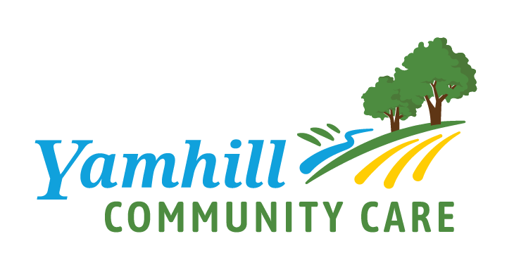
Early Learning Council Facilitator(s): Jenna Sanders

Thursday, August 12, 2021 Timekeeper: TBD

4:00 P.M. – 5:30 P.M. Scribe: Natalie Walker
Location:  Dial-In: | Zoom: https://zoom.us/j/95521367556 Cell Phone controls:  Meeting ID: 955 2136 7556 Press *6 to mute/unmute  Dial in: +1 253 215 8782 Press *9 raise your hand
Attendees:  * denotes absent | Early Learning Council: Amanda Lamb, Amy Egli, Angie Blackwell, Ann Stevenson, Ann Ziehl, Ashley Beavers, Amanda Dallas, Casey Mills, Danielle Ludwick, Eli Cox, Elide Sanchez Rivera, Emily Chadwick, Ian Bergmann, Jen Schulze, Jenna Sanders, Jordan Robinson, Kelly Williams, Kimbre Chapman, Kourtney Ferrua, Larry Soderberg, Lindsey Manfrin, Margaret (Peg) Miller, M.D., Michael Finlay, Mindy Larson, Nicole Hyatt, Odi Campos, Rebecca Ambrose, Russell Mark, Suey Linzmeier, Teressa DiAndrea, Tim Murphy, Tonya Hill, Tracy Taylor-Duffy  YCCO Staff: Jenn Richter, Natalie Walker, Rubit Ramirez, Luis Barajas, Seamus McCarthy
Review Materials: | - Agenda  - Minutes from August 2021  - Executive Brief  - Budget document
Meeting Norms: | Courtesy: respecting time & each other  CARE Agenda: staying on topic  Roles: taking responsibility, prepare by reviewing materials  Evaluation: meeting the goal and following norms

Action (D) Decision, (I) Informational, (P) Presentation or Handout
Time | Topic(s) | Details / Notes / Action Items | Name
4:00 P.M.  (5 mins.) | Welcome |  | Jenna Sanders
4:05 PM  (15 mins.) | Announcements | - Circles from the Start – 9/25  - FWA/Conflict of Interest  - Membership Renewals  - Declaration of Cooperation | Jenn Richter
4:10 P.M.  (15 mins.) | Public Comment |  | Jenna Sanders
4:25 P.M.  (10 mins.) | ELH Overview 2021-23 |  | Jenn Richter
4:35 P.M.  (10 mins.) | ELH Budget Review & Approval |  | Jenn Richter
4:45 P.M.  (10 mins.) | ECE Sector Planning Update | - What has changed in the childcare landscape since 2019?  - Where are you seeing a shift in the need in the community?  - What sources should we be accessing (human or data) to get a full picture of the needs in our community? | Jenna Sanders
4:55 P.M.  (5 minutes) | CIE Revisit |  | Tyler Hartman
5:00 P.M.  (25 mins.) | YCCO Strategic Planning |  | Emily Johnson
5:15 P.M.  (10 mins.) | WESD Resources |  | Cassie Stafford/ Holly Dalton
5:25 P.M.  (5 mins.) | Meeting  Wrap-Up |  | All
Next Early Learning Council: October 14th, 2021, 4:00 P.M. – 5:30 P.M.

