Authorization Contacts for Mental Health, Chemical Dependency, and Physical Health Services for YCCO Members

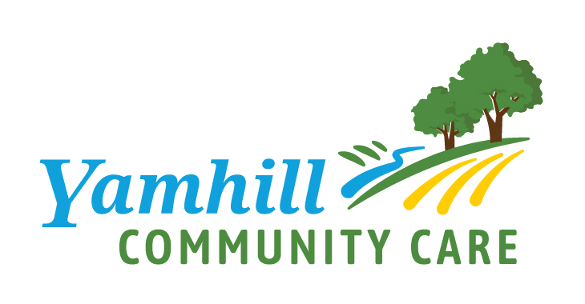

**Please use fax or secure email for transmitting information that contains PHI.**
**Please note: subject lines are NOT encrypted.**

Mental Health and/or Chemical Dependency Services
Including information about A&D outpatient, residential, Medication Assisted Treatment (MAT)

ADULTS and ADOLESCENTS
Name Behavioral Health Customer Service and Authorization Processing
Phone 503-474-6884
E-mail bhauthorizations@co.yamhill.or.us

Fax 503-474-3850

Mailing Address

Yamhill Co. Behavioral Health
627 NE Evans St. McMinnville, OR 97128

Inpatient Psychiatry Hospitalization Services

ADULTS and ADOLESCENTS
Name Behavioral Health Customer Service and Authorization Processing
Phone 503-474-6884 between 8 am - 5 pm; after hours 971-267-0791
E-mail bhauthorizations@co.yamhill.or.us

Medically Monitored Inpatient Detoxification Services (service used to treat severe cases of withdrawal)
Name Behavioral Health Customer Service
Phone 503-474-6884

For personal support, individuals may visit: Adult Behavioral Health Clinic
627 NE Evans St., McMinnville
7:30 am and 6:30 pm M-F
Or call 503-434-7523 and ask to speak with a crisis worker
No appointment needed.

Routine Physical Health Services
Name YCCO Customer Service
Phone 1-855-722-8205

