AGENDA

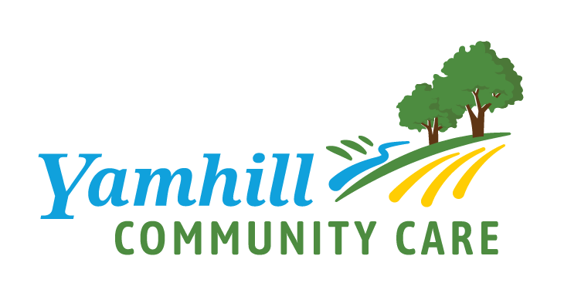
Early Learning Council Facilitator(s): Jenna Sanders

Thursday, February 10, 2022 Timekeeper: TBD

4:00 P.M. – 5:30 P.M. Scribe: Natalie Walker
Location:  Dial-In: | Zoom: https://zoom.us/j/95521367556 Cell Phone controls:  Meeting ID: 955 2136 7556 Press *6 to mute/unmute  Dial in: +1 253 215 8782 Press *9 raise your hand
Attendees:  * denotes absent | Early Learning Council: Amy Egli, Angie Blackwell, Ann Stevenson, Ashley Beavers, Amanda Dallas, Danielle Ludwick, Ian Bergmann, Jen Schulze, Jenna Sanders, Jordan Robinson, Kelly Williams, Kourtney Ferrua, Lindsey Manfrin, Margaret (Peg) Miller, M.D., Michael Finlay, Mindy Larson, Odi Campos, Suey Linzmeier, Teressa DiAndrea, Tonya Hill, Tracy Taylor-Duffy  Guests: Amanda Lamb, Ann Ziehl, Elide Sanchez Rivera, Nicole Hyatt, Rosa Garcia-Moreno, Russell Mark, Tim Murphy  YCCO Staff: Jenn Richter, Natalie Walker, Rubit Ramirez, Keisha Brewster, Traci Porter, Larry Soderberg, Seamus McCarthy
Review Materials: | - Agenda  - Minutes from December 2021  - Parent Engagement flyer  - KPI Pilot Project one-pager  - Final workplan
Meeting Norms: | Courtesy: respecting time & each other  CARE Agenda: staying on topic  Roles: taking responsibility, prepare by reviewing materials  Evaluation: meeting the goal and following norms

Action (D) Decision, (I) Informational, (P) Presentation or Handout
Time | Topic(s) | Details / Notes / Action Items | Name
4:00 P.M.  (5 mins.) | Welcome |  | Jenna Sanders
4:05 PM  (25 mins.) | Announcements | - New staff  - Parent engagement promotion | Jenn Richter
4:15 P.M.  (15 mins.) | Public Comment |  | Jenna Sanders
4:30 PM  (15 mins.) | Early Learning Update |  | Jenn Richter
4:45 P.M.  (10 mins.) | KPI Pilot Discussion & Approval
4:55 P.M.  (10 mins.) | Service Integration Year in Review |  | Rubi Ramirez/ Keisha Brewster
5:05 P.M.  (20 mins.) | Community Health Assessment |  | Emily Johnson
5:25 P.M.  (5 mins.) | Meeting  Wrap-Up | P-3 partners, please stay for a few minutes to select our kinder registration date. | All
Next Early Learning Council: March 10, 2022, 4:00 P.M. – 5:30 P.M.

