What are Community Health Workers (CHWs)?
Community Health Workers
Community Health Workers (CHW’s) are helpers who understand people’s special needs. CHW’s support members by finding community resources to help that person. They also connect people to social services or other people who can help.

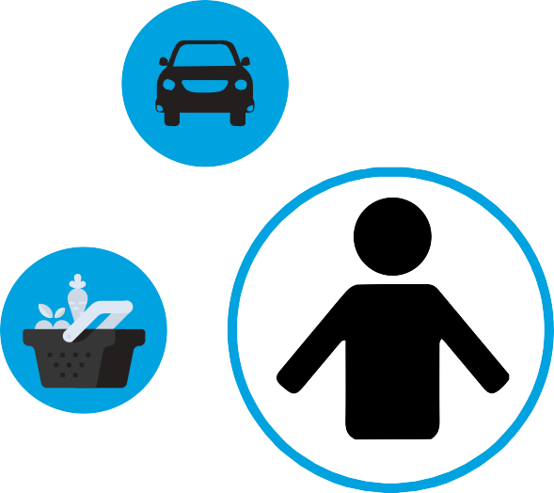
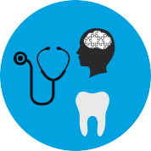
A CHW can:

Help you get a Primary Care Provider or a dentist.
Help you arrange health visits and go with you.
.

Give you resources in your area that may be helpful.
Help you work with healthcare clinic, agencies, or social services.
Tell you about your health benefits.

Find us on Facebook!
YamhillCCO

Office Hours by Appointment Only

Monday-Friday

9 A.M. – 12:00 P.M.
1:00 P.M – 4 P.M
For more questions contact: 503.455.8052
OHP-YCCO-20-092
If you need this in large print, braille or your preferred language, please call us Monday through Friday, 8 a.m. to 5 p.m., at (855) 722-8205 or TTY: 711.

807 NE 3rd Street McMinnville, OR 97128
1-855-722-8205 • TTY/TDD 1-800-735-2900
www.yamhillcco.org

